**Creating Master and Development Branches on GitHub**

1. Login to GitLabs and navigate to project where branches need to be located.



1. Click on project, and empty project should display following message

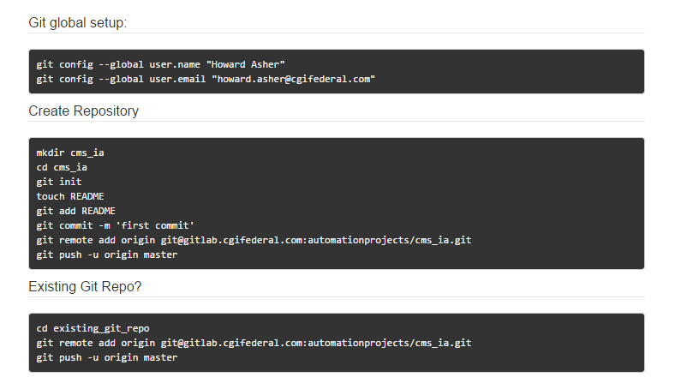

Individual steps from image, allowing copy and pasting

1. mkdir cms_ia
2. cd cms_ia
3. git init
4. touch README
5. git add README
6. git commit -m 'first commit'
7. git remote add origin git@gitlab.cgifederal.com:automationprojects/cms_ia.git
8. git push -u origin master
9. Navigate to Windows Explorer, and create a New

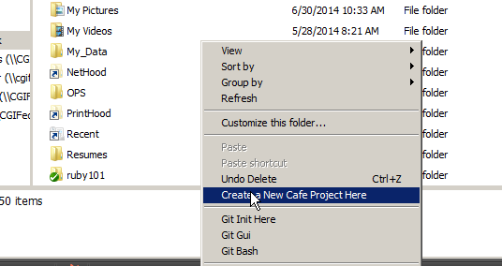

1. Remember where NewCafeProject is located
2. Copy the NewCafeProject, and paste where café scripts are located



1. Rename MyNewCafeProject to Project Name in Github, Example for Automation/CMS_IA, the folder would only be CSM_IA leaving off the Automation description.

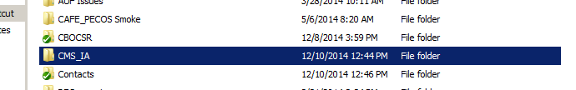

1. Click start and select GitBash bring up the git bash window

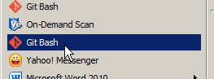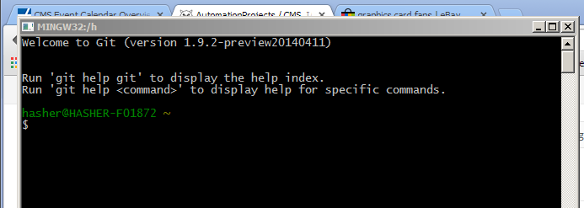

1. Type pwd (lower case) to determine present working directory
2. Navigate to location containing new project (example navigate to CMS_IA folder) by using cd (change directory command), tab key can be used to autocomplete.

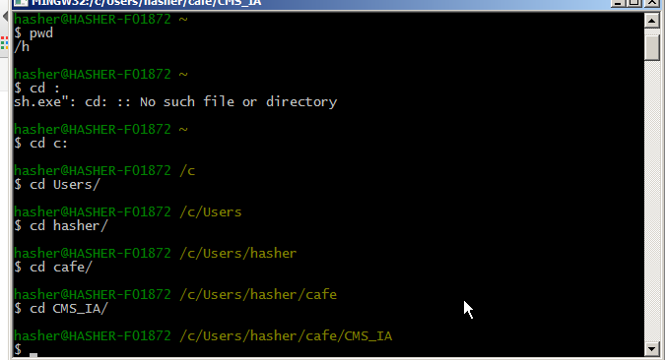

1. After navigating to correct folder
2. Type in steps c through h from above section
3. git init
4. touch README
5. git add README
6. git commit -m 'first commit'
7. git remote add origin git@gitlab.cgifederal.com:automationprojects/cms_ia.git
8. git push -u origin master
9. Navigate to gitlabs web site
10. Click on Activity and click on Branches, then click on new Branch



1. Create development branch cloned from master branch

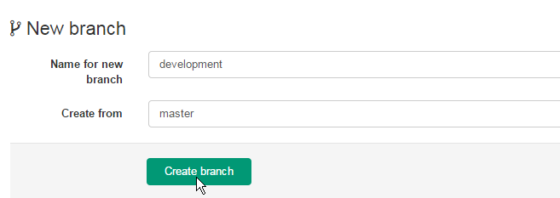

1. Navigate to new folder, right click and select tortoise Git Commit ->master

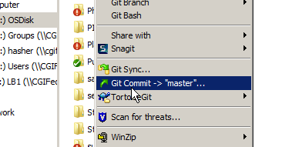

1. Change Branch from master to development by checking the New Branch box
2. Add message of “Initial Push” and click auto sign, at this time the OK button should be activated

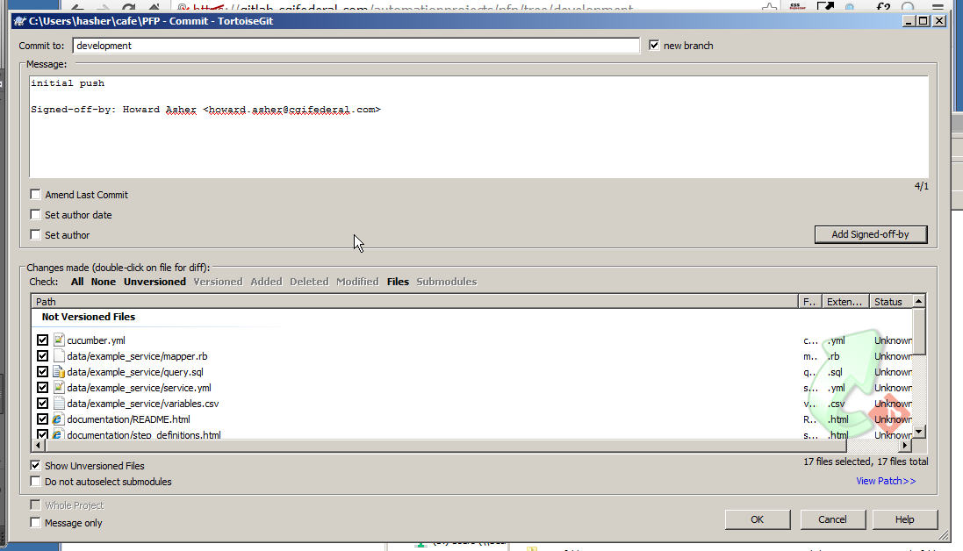

1. Click OK

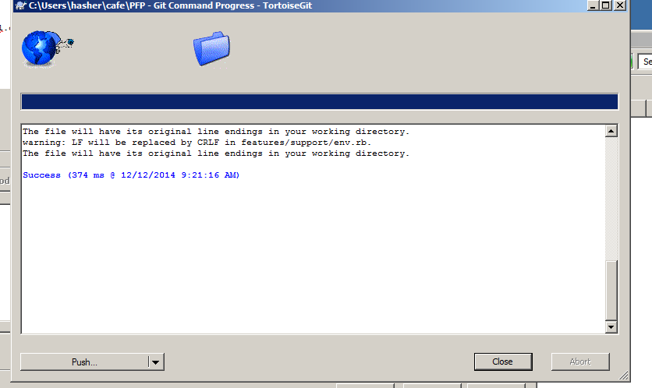

1. Verify that both local, and remote contain ‘development’ if not type in the value

Push into development branch

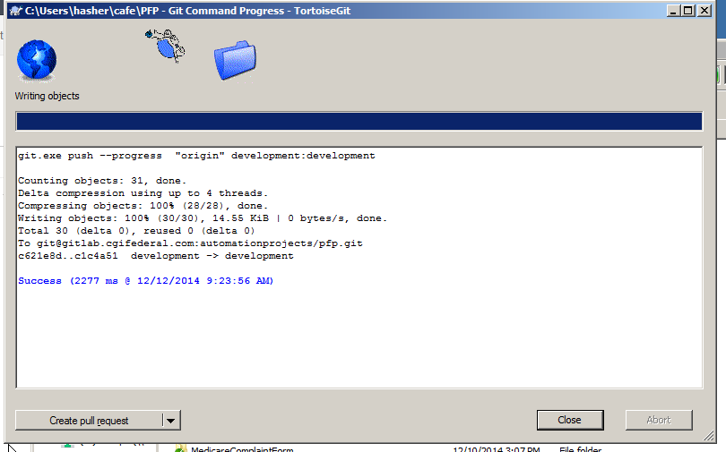

Verify that push was successful, refresh gitlab page

